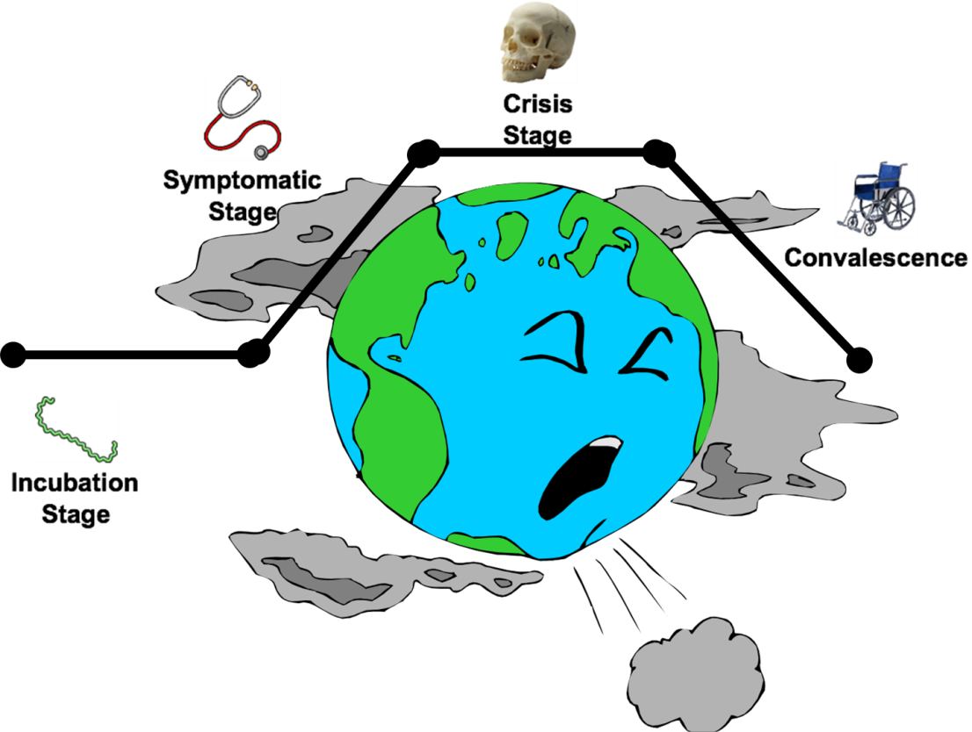
Directions: Write down the description of each stage below while we discuss it with the powerpoint
Incubation Stage Symptomatic Stage Crisis Stage Convalescence Stage (Recovery)
Cold: Cold: Cold: Cold:

Revolution: Revolution: Revolution: Revolution:

