SLO Standard 1-2 Test Review
Hunter-gathers: early humans who did not have permanent dwellings and followed herds of food
Diffusion of Early Civilizations: the spreading of people usually moved by rivers
River Valleys- The location of early civilizations due to rich soil
Code of Hammurabi- The 1st law code from Mesopotamia
Purpose of early writing- laws, communication, records within its own civilization
Theocracy- a government ruled by divine figures (religious people) (example: Egypt’s pharaoh)
Egyptian Pyramids- tombs for deceased pharaohs or important people. Care for the dead=belief in afterlife
Polytheism- belief in more than one god (example: Greece & Roman Mythology)
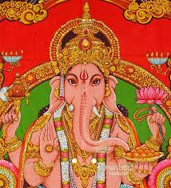Art examples: Which art piece came from China and which came from India?
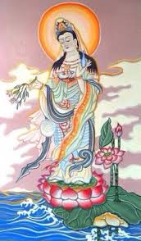

Philosophies from Greek and Chinese: emphasized honesty, humility, virtue, peace
Map of Civilizations: Label each ancient civilization WITH the main religion 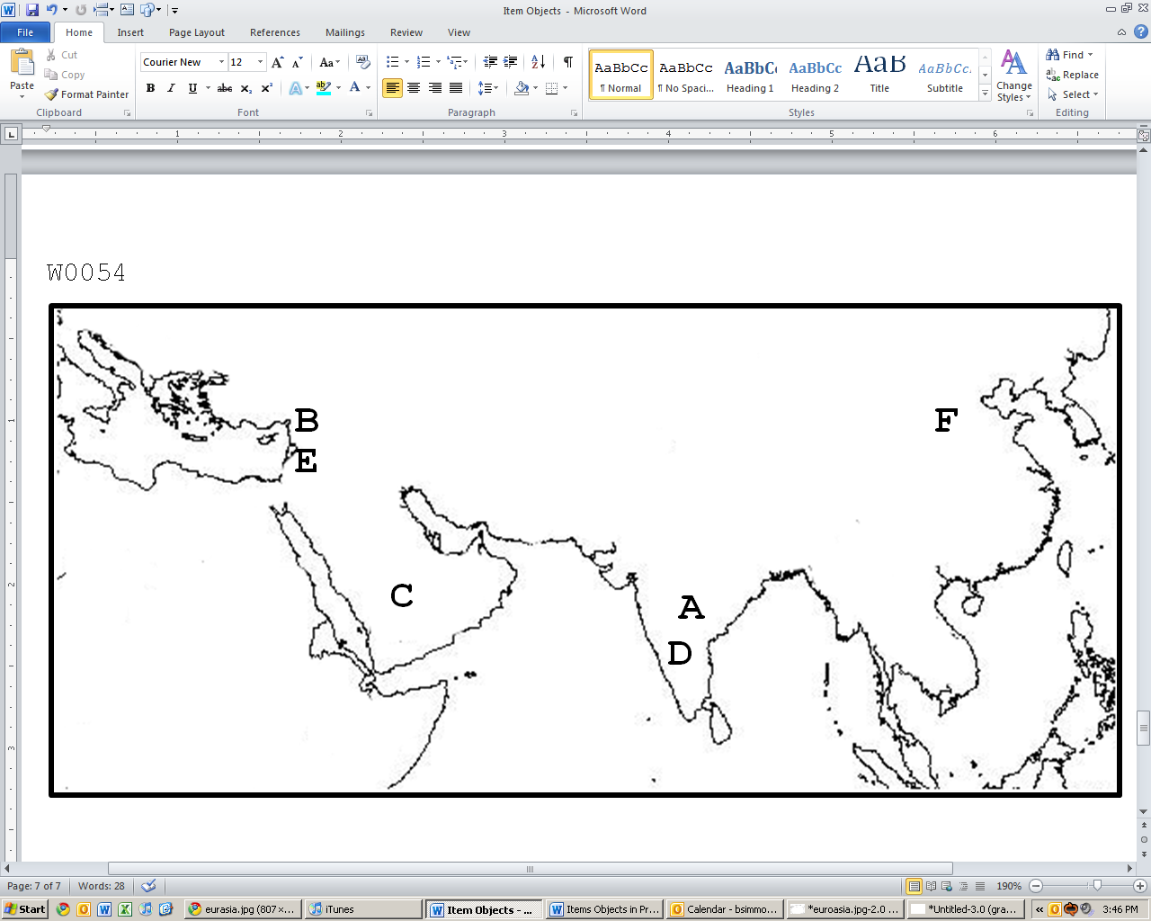
- Civilization:
Religion:

- Civilization: IGNORE
Religion: IGNORE
- Civilization
Religion
- Civilization:
Religion

- Civilization: IGNORE
Religion: IGNORE

- Civilization:
Religion:

Circle all religions that had a single founder
Christianity Buddhism Islam Confucianism Hinduism
Circle all the religions that were monotheistic
Christianity Buddhism Islam Confucianism Hinduism
Mandate of Heaven- Chinese rulers gained and kept their power through divine approval
Monotheism – the belief in one God
Caste System- the social class system in India
Athens- the Greek city-state that focused on democracy, art,
Persia- present-day Iran, went to war with Athens in the Persian War
Julius Caesar- declared “Veni, vidi, vici” before his death meaning “I came, I saw, I conquered”
Trade Routes- helped movement of goods and culture to other civilizations
Greek & Roman Slaves- very important to society and helped the success and building of the empires
Hellenistic Era- Due to Alexander the Great’s conquests
Wonders of the world- One still exists (Pyramids of Giza)
Pompeii- Roman city that was covered by volanco
Families in Rome vs Confucian China- Roman men had all the power, Chinese male roles were determined by relationships
Feudalism- the idea that wealthy land-owners controlled most of the land and peasants could use that land in change for good/money
Women in India- woman’s role was to get married and have children (nothing else!)

