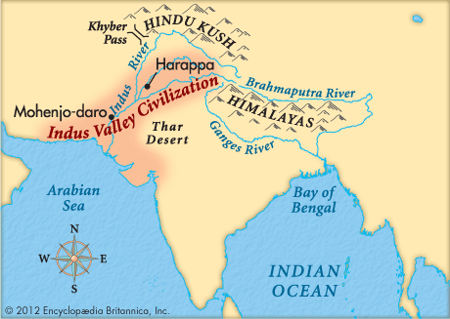  Large Cities/Surplus Food | Specialized Jobs  Indus River Valley | Complex Institutions
Social Structure | Writing | Technology/Art

