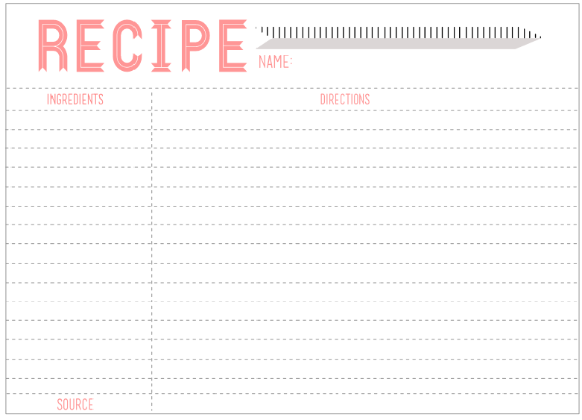

3. Add 5 cups of oppressed peasants. Sit constantly to keep peasants and monarch from separating.

**“A Recipe for Disaster”** By: Lloyd Christmas

1 cracked egg of opportunity

1 large pinch of taxes

“Pope’s Power Italian seasoning”

Economic control (preferably

2 Tablespoons Religious and

5 cups of oppressed peasants

1 Absolute Monarch

8. Serve in either silver dishes or plastic ware (depending on the social class of guests)

7. Pour mixture into a baking dish and baked for 500 years

may boil over.)

6. Add 1 large pinch of taxes (You can add as much as your liking but be careful. Too much and the peasants

separate from the seasoning and could cause mixture to burn)

5. Season with Italian religious & economic control. (Depending on the brand of Absolute Monarch, it may

only add the yolk to the mixture. Whisk until blended.

4. Crack an egg of opportunity but separate the yolk (man) from the whites (woman). Discard the whites and

other ingredients

1. Preheat your oven to a blistering 500 degrees

2. In a saucepan, melt an aged absolute monarch. Be sure it is completely melted so that it combines well with