A 5-Ingredient Recipe for Good Government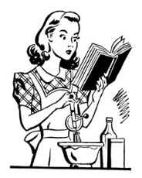
Directions: Using the ideas/philosophies of the major philosophers of the Enlightenment period, create a “recipe for good government”.
You need the following
□ Recipe Title- based on what kind of government you made. (You may want to do this last)
□ Ingredients
1. 5 ideas from 5 different philosophers (Locke, Hobbes, Rousseau, Montesquieu, Voltaire or Wollstonecraft).
2. How much of each item. (cups, tablespoons, pinch, dash, etc)
□ Cooking Directions- (Step-by-step instructions)
- How you will add it to the recipe
- Why you are adding it
- Any helpful tips while making it
□ Picture: Every good cooking recipe has a picture of its final product!

