Ancient Egypt (3100 BC-30 BC) Name:
- Nile River: How did the Nile develop large cities?
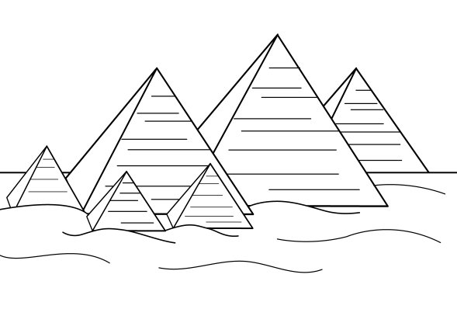
  - Settled near the Nile River (+4,000 miles long)
    - ________________
    - ________________
    - ________________________
    - ________________________
    - ________________
  - Egypt was protected (surrounded by desert)

- Specialized Jobs
  - -specialized work was passed down from father to son
  - -___________________, __________________, ________________
  - -smaller group than Mesopotamia
- Complex Institution
  - Religion
    - ________________
    - _______________________
    - Egyptian Pharaoh (“Son of Re”) was earthly form of supreme Sun god
    - Humans had ___________________
      - Physical body
      - Spiritual body – “____”
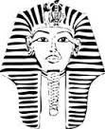
        - Mummify and preserve body so ka can recognize body and return
  - Government
    - led by ___________ (had absolute power. Owned all land, people and possessions
    - Pharaohs passed rule to ________________
    - Bureaucracy- _______________________________________
    - -divided land into 42 provinces and had governors in charge of each
- Social Structure
  - Upper Class:___________________________________________________________
  - Middle Class: __________________________________________________________
  - Lower Class (largest):____________________________________________________
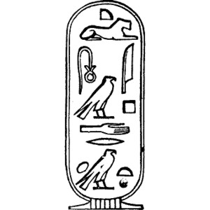
- Writing
  - Hieroglyphics
    - pictures represented words
    - first used on stone then papyrus
    - -used in ______________________________
  - Hieratic script
    - -used for ________________
    - record keeping
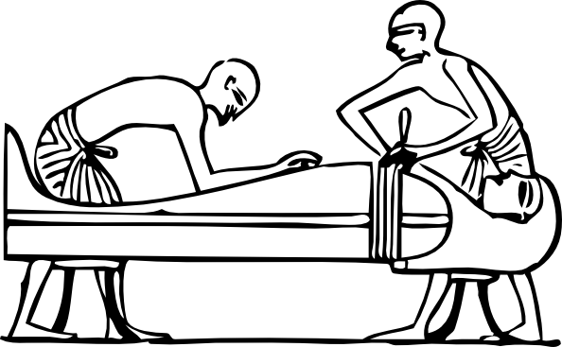
    - business transactions
    - similar but easier and shorter
- Technology & Arts
  - Pyramids/temples
  - Math (knew Area & volume)
  - 365 Day Calendar
  - Medical: ___________________________________________
  - Gold, Silver, copper tools & containers
Egypt’s History: Egypt’s history is divided into 3 different major periods
- Old Kingdom (2700 BC-2200 BC)
  - encompassed Upper & Lower Egypt
  - Started with King Menes
  - Brought wealth through copper minding and trade
  - 1st Dynasty- a dynasty ____________________________________________
_______________________________________________________________
  - Built the __________________________________________
- Middle Kingdom (2055 BC - -1650BC)
  - “Age of Stability”
  - Ruled mostly in Thebes and Memphis
  - Pharaohs _______________________________________________________
  - Created a canal from Nile River to Red Sea
  - Ended with invasion of Hyksos, people from western Asian who had horse drawn chariots, bronze and bows
  - Egypt lacked technological advancements
  - Hyksos ruled for 150
  - Egyptians learned to use ______________________________________________ from Hyksos and then took their empire back
- New Kingdom (1550 BC- 1070 BC)
  - Built temples
  - Hatshepsut- _______________________________ - built great temple near Thebes
  - Her nephew, her successor, conquered much land
  - Akhenaten- changed many of the gods
    - 1st monotheist - believed in ______________
  - Many Egyptians were upset and it weakened the empire
  - Later, King Tutankhamen (King Tut- “boy king”) restored original gods
  - Regardless, empire weakened and Egypt began to be invaded by Nubia, Persians, Macedonians
  - Cleopatra tried to reestablish independence but became too involved in Rome which led to her suicide and defeat.
  - Egypt became __________________________________

