Byzantine Empire Name:
- Shade in the Byzantine Empire and label Constantinople
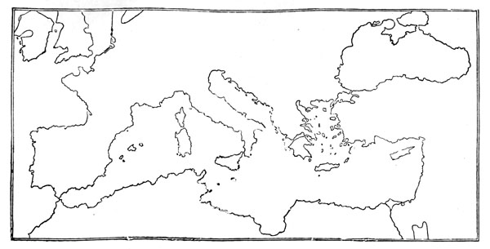
- What are similarities between Romans and the Byzantine Empire?

- Who was Justinian I?

- What was the Justinian Code?

- Why is the Hagia Sophia famous?

- What is the Great Schism?

- What are some different beliefs between the Roman Catholic Church and the Eastern Orthodox Church?

